How to Integrate GPS & Location Tracking in Apps?
Focus Keyword: Location Tracking Apps
Meta title: Integrate GPS & Location Tracking in Apps | Step-by-Step Guide
Meta description: Learn how to integrate GPS & location tracking in mobile apps. Explore APIs, permissions, real-time tracking, and best practices for accurate location features.
Feature image:
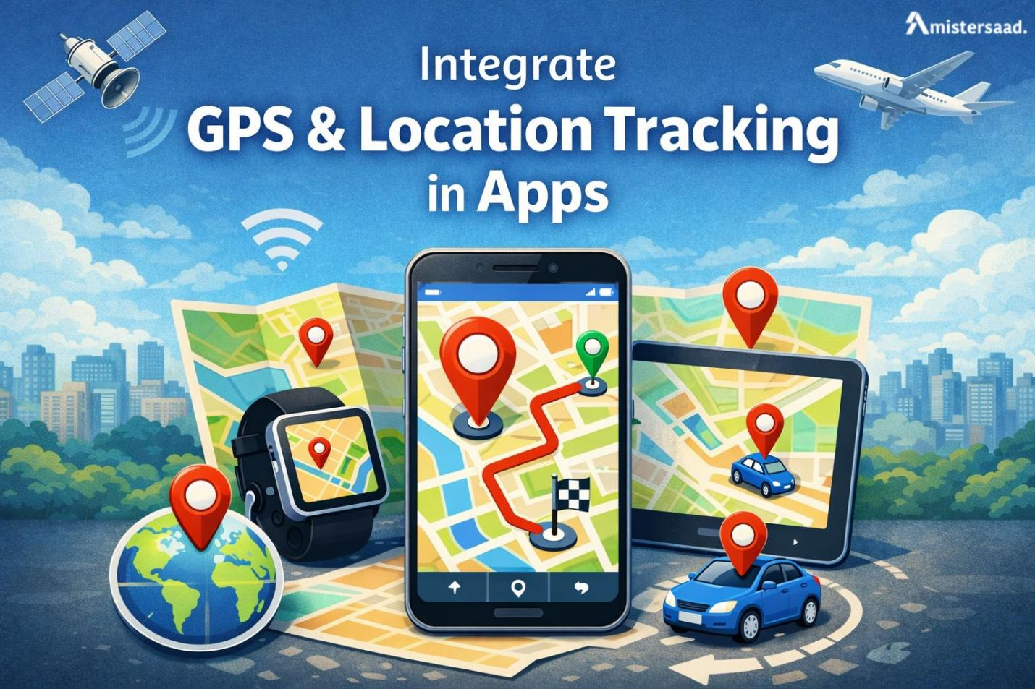
The GPS enabled features have become useful in daily digital activities around the world. Location based services assist apps to provide timely and personalized experience. Most industries rely on proper positioning to be efficient and grow. Location data are essential in transportation, medical, and shopping applications. GPS tracking enhances the quality of navigation, safety and the quality-of-service delivery. The users demand accurate outcomes and low energy consumption. Integration of location technologies requires developers to be familiar with them. This guide describes concepts, tools, and best practices in a clear manner. It puts emphasis on performance, privacy and scalability. These techniques are implemented by many professionals like App Developer Dubai teams. The material will assist you in developing trustworthy and conforming solutions. Explanations are clear, which guarantees high readability and practicality.

Understanding GPS & Location Tracking Technology
Location tracking uses multiple technologies to determine device positions. GPS remains the most common global positioning method. Other systems complement GPS for better accuracy indoors. Location data depends on hardware sensors and software algorithms. Smartphones use satellites, networks, and sensors together. Accuracy varies based on environment and signal strength. Urban areas often cause signal reflections and errors. Developers must understand these limits before implementation. Proper configuration reduces inaccuracies and improves reliability. Many Freelance App Developer Dubai professionals study these fundamentals. Knowledge of tracking methods helps choose the right solution. This section explains core concepts in simple terms. Understanding technology ensures better design decisions. It also improves user trust and application performance.

What Is GPS and How It Works
GPS uses satellites orbiting Earth to calculate positions. Devices receive signals from multiple satellites simultaneously. The system measures signal travel time precisely. Triangulation then determines the device location. More satellites improve accuracy significantly. GPS accuracy ranges from meters to several meters. Weather and buildings can reduce precision. Urban environments often create signal interference. GPS works best outdoors with clear sky views. Smartphones include GPS receivers for this purpose. Developers access GPS data through platform APIs. Understanding this process helps optimize tracking logic. Efficient usage reduces battery drain and improves accuracy.

Types of Location Tracking Technologies
Location tracking extends beyond satellite systems. Different technologies support various environments and accuracy needs. Combining methods improves reliability and performance.
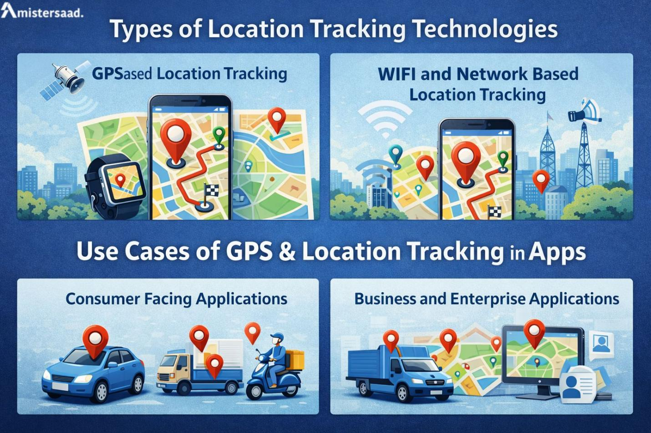

GPS Based Location Tracking
GPS tracking provides global outdoor accuracy. It works best for navigation and travel applications. Battery usage remains higher during continuous tracking.

WIFI and Network Based Location Tracking
Network tracking uses nearby Wi-Fi33 and cell towers. It performs well indoors and urban areas. Accuracy depends on network density and signal quality.

Use Cases of GPS & Location Tracking in Apps
Location tracking supports many real-world applications today. Consumer apps use it for convenience and personalization. Businesses depend on tracking for efficiency and control. GPS features enhance safety, planning, and decision making. Many startups build services around location intelligence. Accurate tracking improves user satisfaction and retention. Developers must align use cases with user expectations. Ethical handling of location data remains critical. This technology supports innovation across multiple industries. Many Mobile App Developer Dubai teams design such solutions. Understanding use cases helps prioritize features. It also guides technical and business decisions effectively.

Consumer Facing Applications
Ride hailing apps depend on real time tracking. Delivery services use GPS for route optimization. Fitness apps track workouts and outdoor activities. Health platforms monitor movement patterns responsibly. Social apps use location for discovery features. Dating platforms match users based on proximity. These apps require high accuracy and responsiveness. User consent remains essential in all cases. Developers must balance functionality and privacy carefully. Consumer trust drives long term success.

Business and Enterprise Applications
Fleet systems track vehicles and optimize routes. Logistics apps monitor shipments in real time. Enterprises track assets for security and efficiency. Workforce apps monitor field employee locations. These systems improve accountability and productivity. Data accuracy supports better operational decisions. Businesses require secure and scalable tracking solutions. Integration with backend systems remains essential. Reliability directly impacts business performance.

Choosing the Right Location Tracking Method
Selecting a tracking method affects app performance greatly. Developers must consider accuracy and power consumption. User expectations vary by application type. Real time tracking suits navigation and safety apps. Periodic tracking fits analytics and monitoring needs. Environmental conditions also influence method selection. Indoor apps need network-based solutions. Outdoor apps benefit from GPS accuracy. Many Freelance Mobile App Developer Dubai professionals evaluate these factors. The right choice improves usability and efficiency. Poor selection leads to user dissatisfaction and battery complaints.
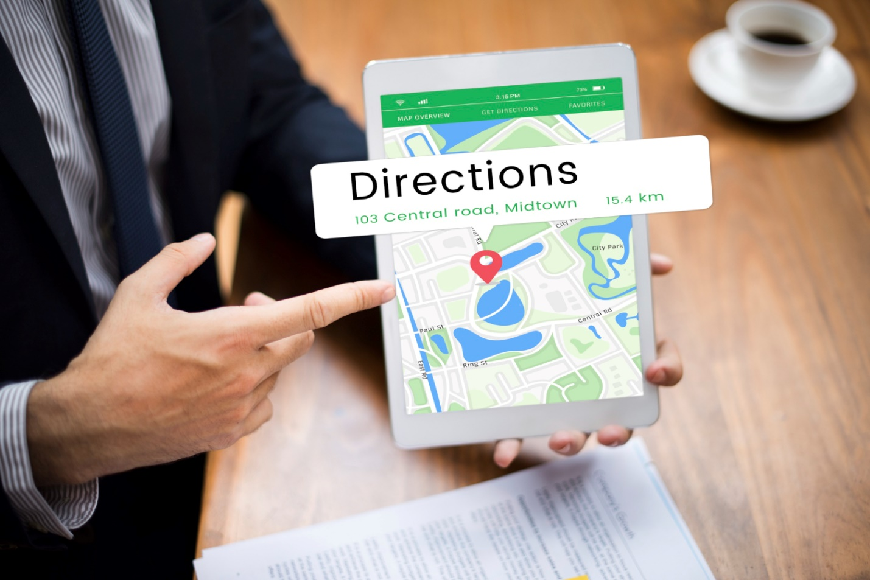

Real Time vs Periodic Location Tracking
Real time tracking update’s locations continuously. It suits navigation and live monitoring. Periodic tracking collects data at intervals. It saves battery and resources. Continuous tracking consumes more power. Interval tracking balances accuracy and efficiency. Developers choose based on feature requirements. User settings can control update frequency. Flexibility improves user experience significantly.

Accuracy vs Battery Consumption Tradeoffs
High accuracy tracking drains battery faster. Lower accuracy saves power but reduces precision. Developers must find the right balance. Adaptive strategies adjust accuracy dynamically. Motion detection helps reduce unnecessary updates. Background tracking requires careful optimization. Efficient algorithms improve both accuracy and battery life.

Required Permissions and Privacy Compliance
Location tracking requires explicit user permissions. Platforms enforce strict privacy rules today. Transparency builds trust and legal compliance. Users must understand data usage clearly. Apps should request permissions responsibly. Background access needs strong justification. Developers must follow regional privacy laws. Secure handling of location data remains critical. Many App Development Dubai projects emphasize compliance. Failure leads to app rejections or penalties. Ethical practices ensure long term sustainability.

Location Permissions on Android and iOS
Android and iOS require permission prompts. Foreground access allows usage during active sessions. Background access needs additional approval. Clear explanations improve consent acceptance. Users prefer control over location sharing. Developers should request only necessary permissions. Respecting user choice improves ratings and trust.

Data Privacy and Legal Compliance
Privacy laws regulate location data usage. GDPR enforces strict consent requirements. Regional laws may add further obligations. Apps must publish clear privacy policies. Data minimization reduces legal risks. Secure storage protects user information. Compliance builds credibility and avoids penalties.

Integrating GPS in Android Applications
Android provides robust location APIs for developers. Google Play Services simplifies GPS integration. Developers use the Fused Location Provider. It combines multiple signals intelligently. Proper setup ensures accurate and efficient tracking. Android requires runtime permission handling. Background tracking needs special configurations. Many Mobile App Development Dubai teams follow these practices. Testing ensures reliable performance across devices. Optimization improves battery efficiency and user satisfaction.

Android Location APIs Overview
The Fused Location Provider offers unified access. It selects the best location source automatically. Developers set accuracy and update intervals. Google Play Services handle sensor fusion. This approach improves reliability significantly. APIs support geofencing and activity recognition. Proper usage reduces development complexity.
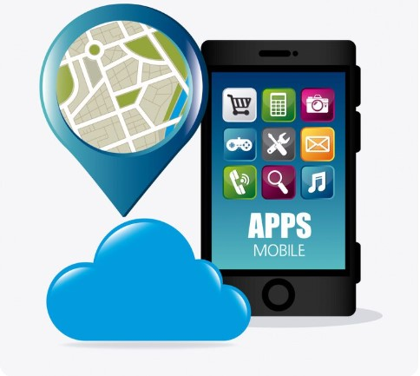

Step by Step GPS Integration in Android
Developers first request runtime permissions. They configure location request parameters. The app then subscribes to location updates. Background tracking requires service configuration. Developers must handle permission denials gracefully. Testing ensures smooth operation across scenarios.

Integrating GPS in iOS Applications
iOS uses the Core Location framework. It provides precise location services. Developers configure CLLocationManager settings. Permission handling follows strict guidelines. Background modes require explicit declaration. Many Freelance Mobile App Development Dubai professionals master these steps. Proper integration ensures smooth tracking. Testing across devices remains essential. Optimization improves battery performance and accuracy.

Core Location Framework Overview
Core Location manages location updates efficiently. Developers set desired accuracy levels. Distance filters control update frequency. The framework supports region monitoring. It balances precision and power consumption automatically.
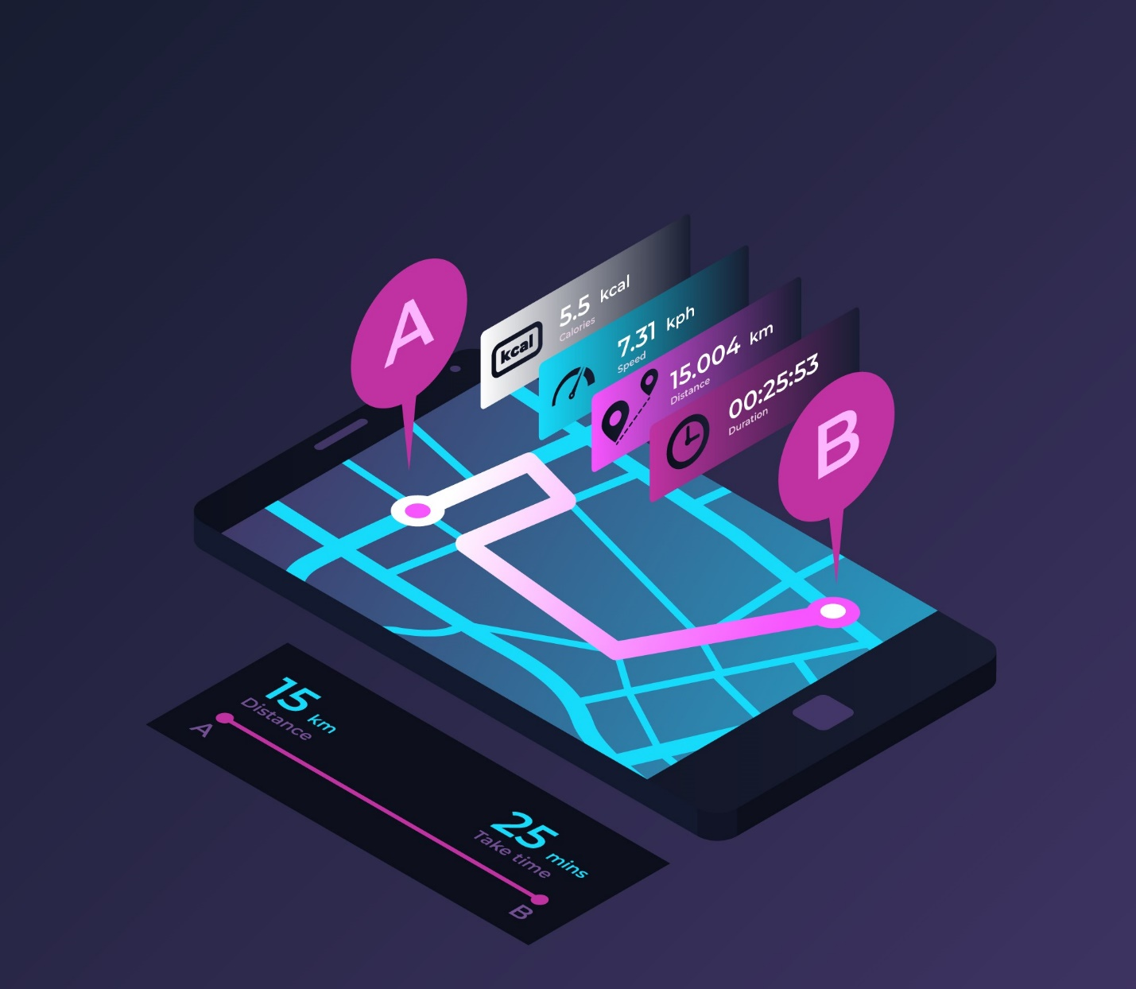

Step by Step GPS Integration in iOS
Configure permission descriptions in the project. Request appropriate authorization levels. Initialize CLLocationManager correctly. Set accuracy and distance filter values. Start receiving location updates. Handle authorization status changes properly. Enable background modes when required. Test background behavior thoroughly. Stop updates when unnecessary. Handle errors gracefully. Proper setup ensures compliance and stability.

Backend Integration for Location Data
Location data often flows to backend servers. APIs handle data transmission securely. Real time processing supports live features. Storage solutions manage large datasets. Scalability remains critical for growth. Many teams integrate analytics platforms. Efficient backend design improves performance. This approach supports enterprise requirements effectively.

Sending Location Data to Servers
APIs receive location updates securely. HTTPS ensures encrypted transmission. Authentication prevents unauthorized access. Rate limiting protects server resources. Efficient payloads reduce network usage.

Storing and Processing Location Data
Databases store geospatial information efficiently. Indexing improves query performance. Real time processing supports alerts. Analytics extract valuable insights. Data retention policies ensure compliance.

Displaying Location Data on Maps
Maps visualize location data clearly. Users expect intuitive map interfaces. Integration requires proper SDK setup. Markers and routes enhance usability. Performance optimization ensures smooth rendering. Many apps rely on mapping services today.


Integrating Google Maps and Apple Maps
SDK setup requires API keys. Developers add markers for locations. Routes display navigation paths. Custom styling improves visual appeal. Performance testing ensures smooth interaction.

Advanced Map Features
Geofencing triggers location-based actions. Heatmaps visualize activity density. Clustering manages multiple markers. These features enhance data understanding significantly.

Performance Optimization and Battery Efficiency
Efficient performance ensures long lasting user engagement. Poor optimization causes battery complaints and app uninstallations. Location tracking must adapt to user behavior patterns. Smart configurations reduce unnecessary resource usage. Developers should avoid constant high accuracy tracking. Balanced strategies protect battery life effectively. Background processes need strict control. Efficient algorithms improve responsiveness and stability. Performance testing helps detect excessive power consumption.

Reducing Battery Drain
Adaptive tracking intervals adjust updates based on movement. Stationary devices require fewer location requests. Motion detection strategies use sensors intelligently. Accelerometers detect movement changes efficiently. Apps pause tracking during inactivity. This approach saves significant battery power. Developers can reduce GPS usage frequency. Network based tracking activates only when required. Background services should run minimally. User settings can control tracking intensity. Efficient scheduling lowers processor load. These strategies improve user satisfaction and retention. Battery friendly apps perform better in competitive markets.

Improving Location Accuracy
Sensor fusion techniques combine multiple data sources. GPS works alongside WIFI and motion sensors. This approach improves precision significantly. Error handling manages signal loss situations. Apps detect inaccurate readings promptly. Fallback methods switch to network-based tracking. Developers must validate incoming data carefully. Filtering algorithms remove sudden location jumps. Consistent accuracy builds user trust. Reliable data supports advanced app features. Accurate tracking enhances navigation and analytics. Precision remains critical for location dependent services.

Security Challenges in Location Tracking Apps
Location data requires strong protection measures. Unauthorized access risks user privacy severely. Developers must secure every data transmission. Sensitive information should remain encrypted always. Access controls restrict data usage internally. Authentication verifies trusted devices and servers. Secure API authentication prevents misuse. Tokens and keys need safe storage. Encryption best practices protect stored records. Regular security audits identify vulnerabilities early. Compliance with privacy laws remains mandatory. User trust depends on transparent security practices. Strong security ensures long term application credibility.

Testing and Debugging Location Tracking Features
Testing validates accuracy and performance across scenarios. Simulating GPS locations helps test movement paths. Developers evaluate behavior without physical travel. Handling edge cases prevents unexpected failures. Poor signals and location jumps need testing. Background tracking requires special validation. Apps must behave correctly when minimized. Cross device testing ensures hardware compatibility. Different sensors affect tracking results. Testing improves stability and user confidence. Debugging tools help identify performance issues. Thorough testing reduces post release errors significantly.

Future Trends in GPS & Location Based Apps
AI powered location insights improve decision making. Predictive analytics enhance user personalization. Indoor positioning systems gain business adoption. Malls and airports use indoor navigation increasingly. Augmented reality navigation blends digital and physical spaces. Location context enhances immersive experiences. Privacy first location tracking gains importance globally. Users demand transparency and control. Regulations push ethical data usage practices. Edge computing improves real time processing. Innovation continues to reshape location-based applications rapidly.

Conclusion
GPS integration involves planning and precision. Developers must understand location technologies deeply. Choosing the right tools ensures stable performance. Each platform offers robust location capabilities. Battery efficiency requires smart optimization strategies. Accuracy improves through sensor fusion and testing. Privacy and security remain top priorities. Proper testing ensures reliability across devices. Balanced design improves user satisfaction significantly. Location tracking continues evolving with new technologies.

FAQS
What is GPS integration in mobile applications?
GPS integration allows apps to access real time device location accurately.
Which location tracking method is most accurate?
GPS offers the highest accuracy in outdoor environments.
Does GPS tracking affect battery life?
Yes continuous tracking can increase battery consumption.
How can developers reduce battery drain from location tracking?
They can use adaptive intervals and motion detection.
Are location tracking apps legally compliant?
They are compliant when following GDPR and regional regulations.

